Design Optimization and Performance Evaluation of a Hyperspectral Imager for Low-Earth Orbit small satellites

- System Specification
Specification | Value
Imager Type | Pushbroom
Orbit | Sun Synchronous Orbit
Spectral Range | 400-900nm (VNIR)
Spectral Resolution | 10nm
GSD at 500km | 9.7m
MTF | ≥ 0.45 at 100lp/mm
Volume | 1.5U
Grating Shape | Flat
Spectrometer Form
Entrance Pupil Diameter | 55
FOV | 2.23degrees
Slit Width (um)
Slit Length (mm)
System F-number | 3.2
Spectrum Length (mm)
Pixel Size (um) | 5.5
Spectral Sampling (nm)
Smile Distortion 9%pixel/um)
Keystone Distortion (%pixel/um)

Table 1. Proposed Imager Specification

Upon thorough verification of the performance degradation of the deployment system and its associated variations, the final specifications of the system can be deduced, considering the system's sensitivity. Subsequently, a system design can be conceptualized, with meticulous attention to the required deployment range and the necessary compensation for the conceptual design. The design requirements for the hyperspectral imager are given in table 1.1 above.
The instrument was specifically designed for precision agriculture, with its design requirements tailored to suit this purpose. Emphasis was placed on achieving the necessary spectral resolution essential for precise red-edge spectral sampling in advanced precision agriculture applications, while also considering cost to enhance accessibility to the technology.

2. System Design Process
Initial design and performance requirements were set, and the optical system is drafted based on these first-order specifications. Achieving an optimal design often requires multiple iterations, given the intricate relationships among various performance metrics [1]. In cases where balancing these metrics proves challenging, it may be necessary to refine the design through numerous iterations. As a final resort, one or more design requirements may need to be relaxed to prioritize meeting another, more critical requirement. This iterative process ensures that the final design strikes the best possible balance among competing objectives while fulfilling the most essential performance criteria. In the case of the proposed imager, SNR, MTF, GSD, were considered crucial design requirements.
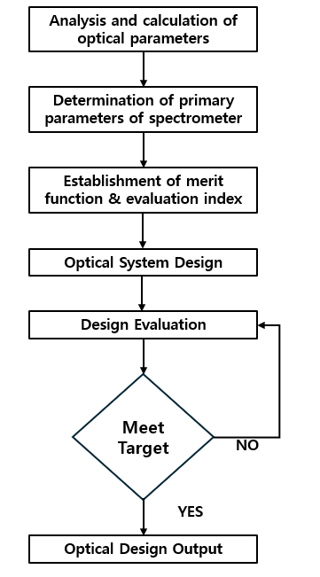

Figure 2.1 Flowchart of the design iteration process in engineering

2.1 Fore Optics Design
Fore optics is a simple catadioptric Cassegrain telescope. The Cassegrain telescope utilizes two distinct mirrors: one concave and one convex. Positioned at the base of the telescope tube, the primary mirror is parabolic in shape with a central opening. Meanwhile, the secondary mirror, which is hyperbolic and convex, is smaller in size and placed near the top of the tube, within the focal point of the primary mirror [2].
The catadioptric telescope captures imagery at an altitude of 500km, projecting it onto a slit measuring 5.8 X 5.8µm. This setup provides a ground sampling distance of 9.7m with a FOV of 2.328 degrees. The telescope features an entrance pupil diameter of 55 mm and operates with a focal length of 300 mm (f/4.6). The one latter lens, positioned near the slit plane, address minor residual aberrations.
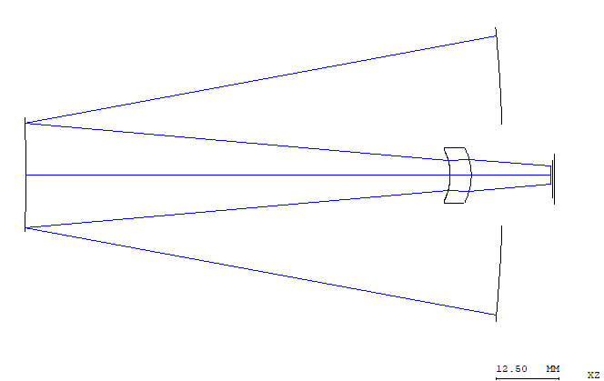
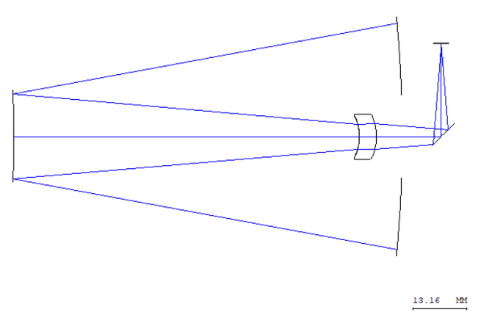
Figure 2.2 The layout of the final Catadioptric Cassegrain fore optics design

2.2 Spectrometer design
The spectrometer is a compact, freeform on-axis catadioptric optical system. The configuration employs a folded optical path facilitated by planar fold mirrors, allowing the system to maintain a reduced volume suitable for small satellite platforms. Incoming light is first collimated by a refractive element before being spectrally dispersed by a planar reflective grating element. The dispersed rays are then focused on the image plane by a triplet lens element that also correct off-axis aberrations without introducing significant tilt or decentering.
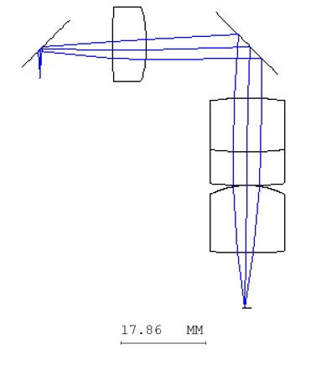

Figure 2.3. The layout of the freeform spectrometer Design

2.3
Ensuring a seamless integration between the fore optics and spectrometer entails aligning the output rays of the former with the input rays of the latter at their connection plane. Ideally, this alignment would occur without compromising the individual image quality of each system. However, achieving this ideal scenario is impractical. Instead, in practice, certain first-order quantities are matched as an approximation of perfect alignment. There are several types of system matching that were considered some of which are F-number match at an internal image, pupil match in the space of collimation, perfect match for every ray, and F-number and chief ray match in a general internal image[1].
In this optical system, the connection plane is located at an internal image plane of the entire system and is telecentric in both systems, matching the F-number or numerical aperture can establish a first-order match, as depicted in Figure 2.4

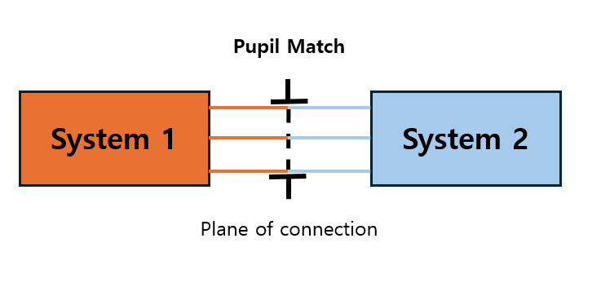

Figure 2.4 Pupil match in the space of collimation schematic

2.4 Combined System Optimization
After aligning the two subsystems, joint optimization was performed using CODE V. In this process, only the primary and secondary mirrors were adjusted, while all other parameters remained fixed. The initial field Y angles were set to 0.15, 0.25, and 0.35 but were subsequently modified to achieve a sharper image at the plane of interest. The optimization targeted not only the imaging quality at the final spectral plane but also the performance at the slit, incorporating both into the error function. Results showed that key metrics such as the system’s MTF, RMS spot size, and smile distortion confirmed the optical system’s high-quality performance.
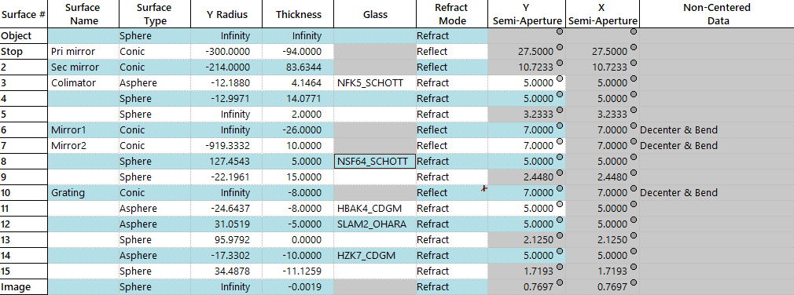
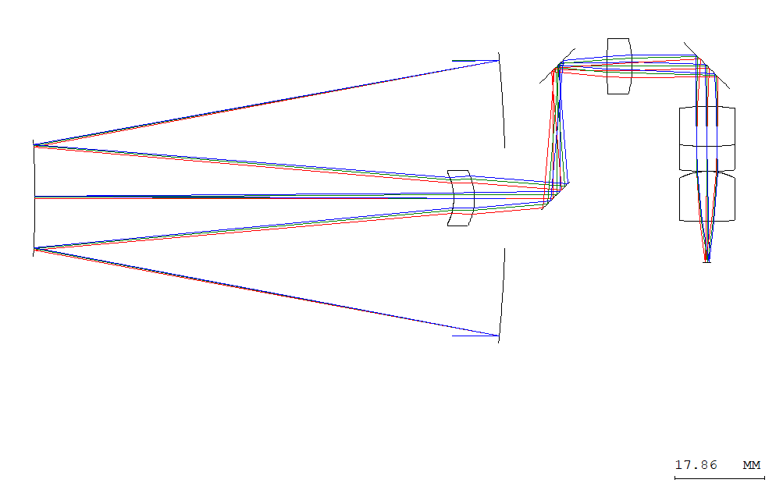
Table 2.1 Optical data of the combined hyperspectral Imager in the CODE V format (Unit: distance in mm, angle in deg)
Fig.2.5 Combined system match using ‘pupil match.’

REFERENCE
[1] C. Joseph Middleton, “A Holistically Designed Hyperspectral Imager For CubeSats,” 2022.
[2] Ö. Karci, “A simulation and experimental validation of third-order coma in nodal aberrationtheory with a Cassegrain telescope,” Turkish Journal of Physics, vol. 45, no. 6, pp. 378–389, 2021, doi: 10.55730/1300-0101.1002.

